Queen Elizabeth II
90th Birthday Celebrations

………………………………………………..
was rung on 11th /12th June, 2016
at …………………………..……….
in celebration of the Queen’s Official
90th Birthday by the following ringers

- ………………………………………..
- ………………………………………..
- ………………………………………..
- ………………………………………..
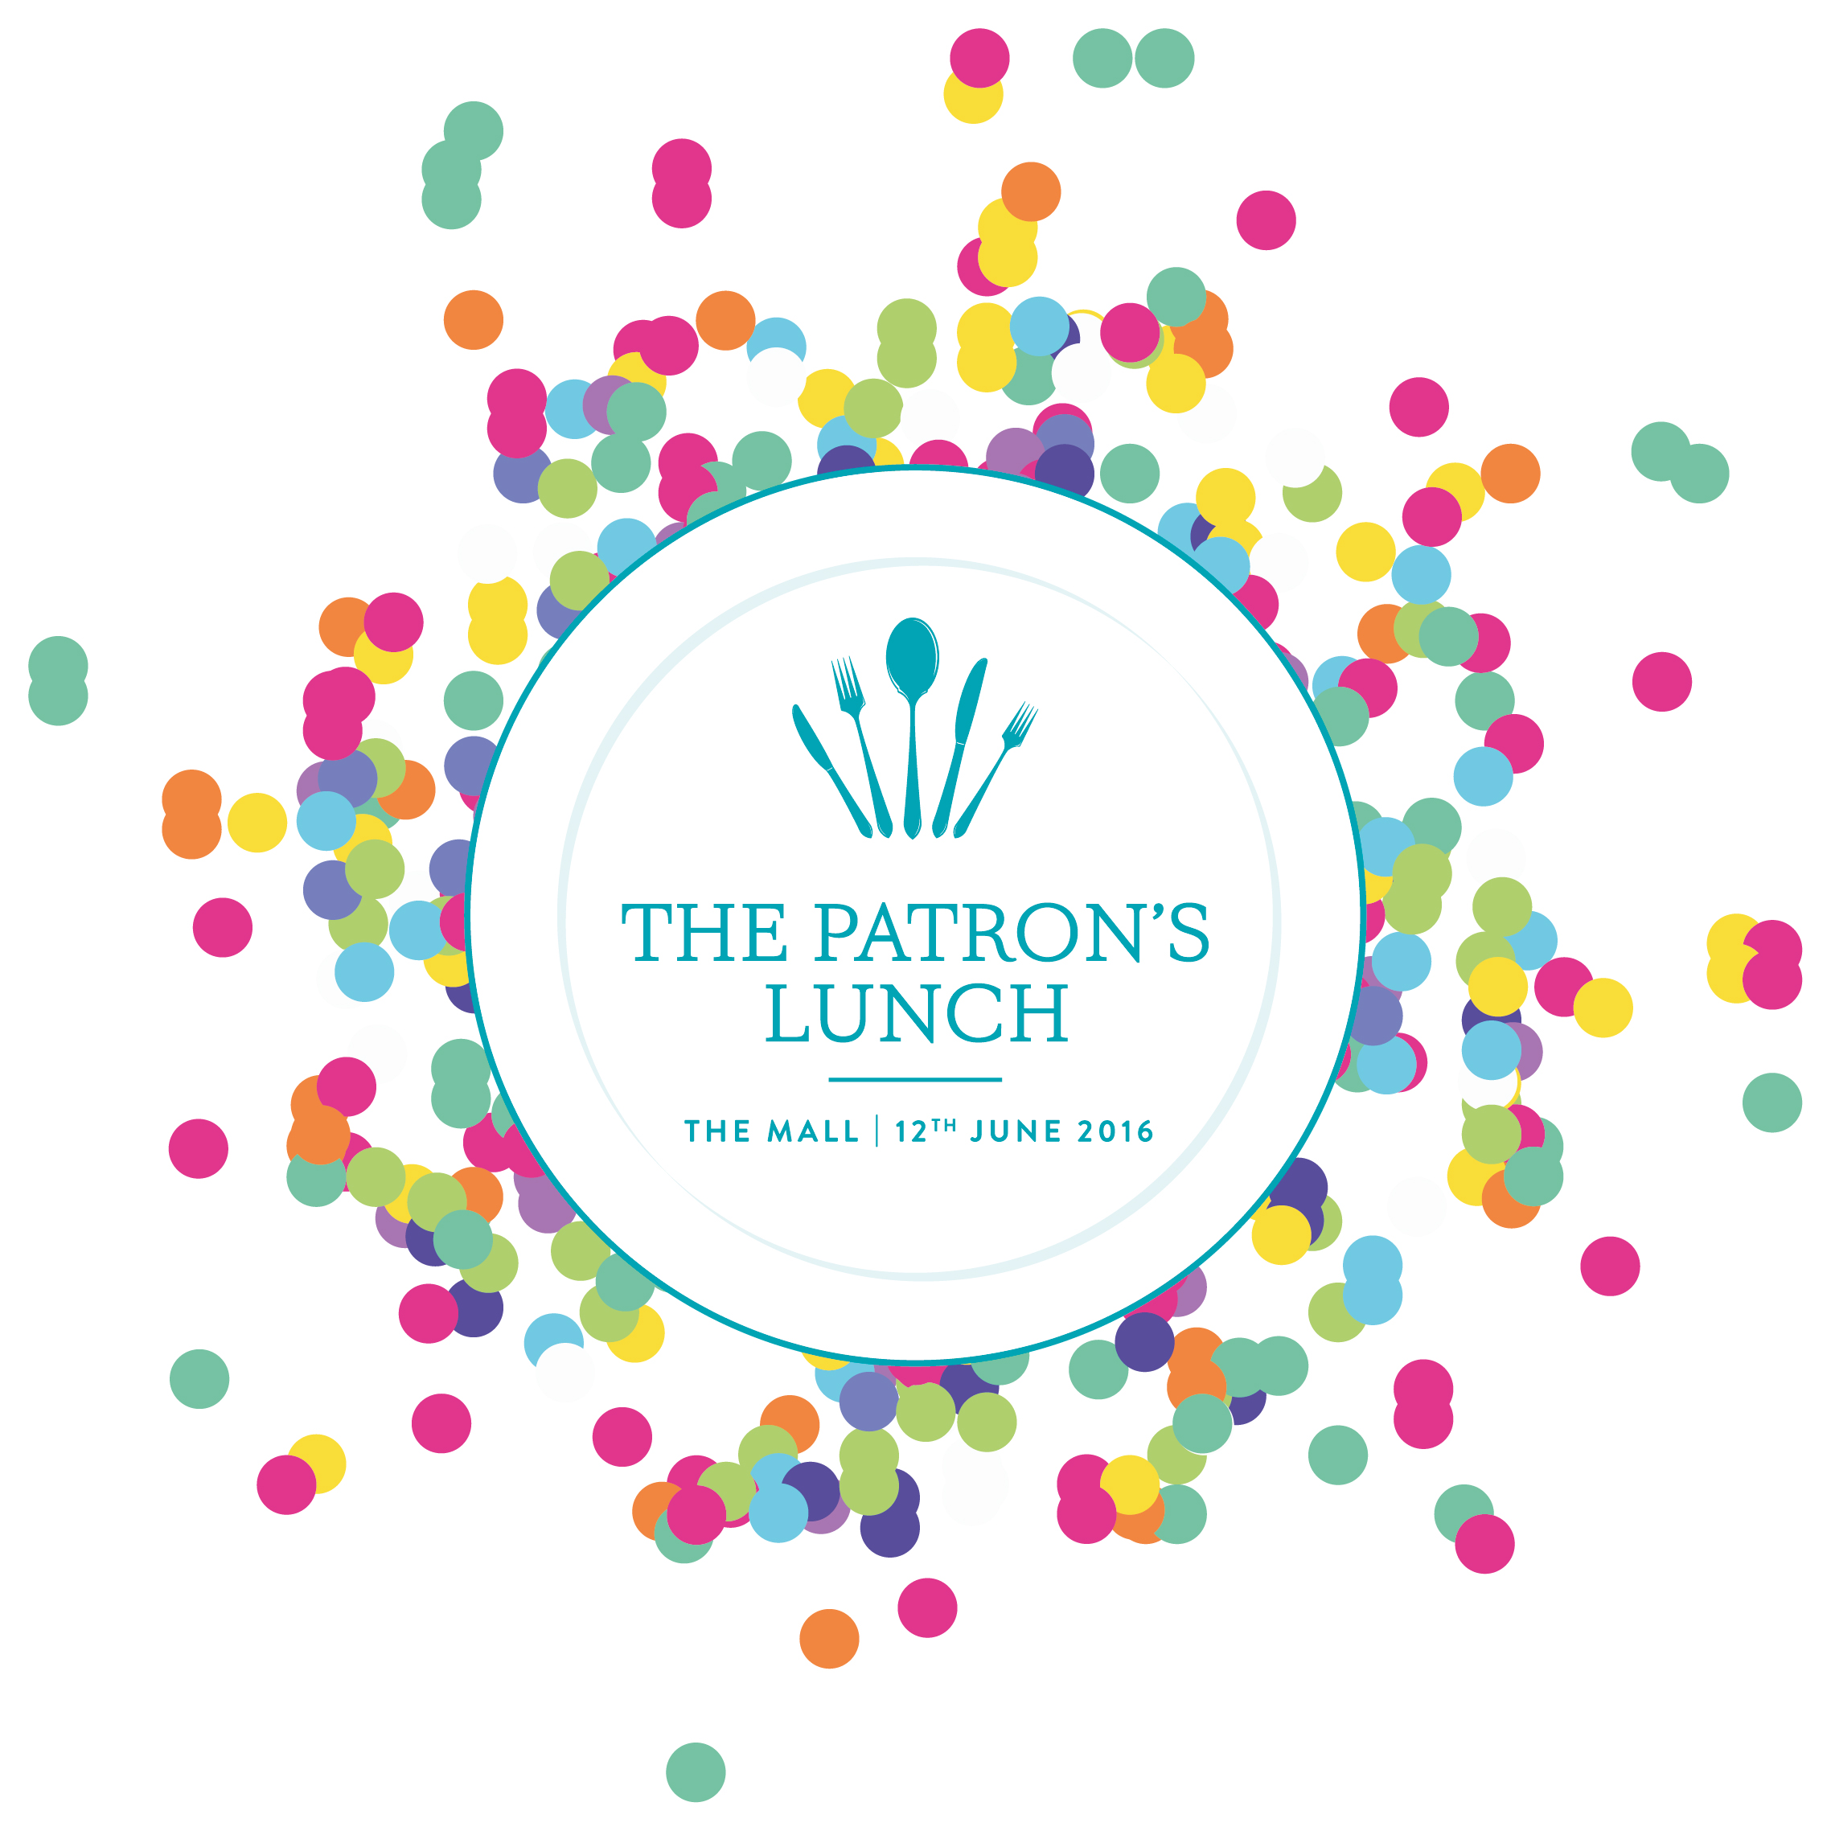
- ………………………………………..
- ………………………………………..
- ………………………………………..
- …………………………………………
Conducted by:

