 | Safeguarding Information for Ringers  Produced by The Central Council of Church Bell Ringers and  Peterborough Diocesan Guild of Church Bellringers |  |  | 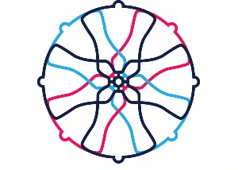
Urgent concerns  about a child or adult  and immediate  response required | Refer directly to:  AND | Record and report concerns  to:  Parish Safeguarding Officer  Insert name and phone number | In an emergency – Police and Ambulance: dial 999  Police non-emergency: dial 101  Social Care Services: East Sussex 01323 4640222  Brighton and Hove 01273 290 400  West Sussex 01403 229 900  Childline: 0800 11 11  NSPCC : 0808 800 5000 or email help@nspcc.org  Silverline: 0800 470 80 90 (for older adults)
Concerns about a child  or adult in need  or at risk of harm |  | Or the incumbent  Insert name and phone number
Concerns about a OR  ringer from another  tower |  | Or contact the Diocesan Safeguarding Advisors directly | Chichester Diocesan Safeguarding Advisers  safeguarding@chichester.anglican.org  Colin Perkins 01273 424 030  Vicky Martin 01273 421 021 | Next steps, as advised
Record and report to the SCACR Safeguarding Lead
Val Clay
safeguarding@scacr.org
01903 693587

Concerns about anyone or anything that may put you or someone else at risk of harm (including concerns about people in a position of authority in the church; people who attend services, groups or activities; anyone else) | - Record ALL actions and store securely  - Remember the safety and welfare of any child or adult takes precedence over all other concerns. This includes confidentiality and personal loyalties  - Consider the support needs of all who might be affected by allegations of abuse – including you.  - It is essential that all Tower Captains (etc) know who their Parish Safeguarding officer is and understand the Safeguarding officer’s role and responsibilities.  - Definitions of abuse of vulnerable adults can be found at The National Domestic Abuse Helpline https://www.nationaldahelpline.org.uk/ or 0808 2000 247  - Definitions and signs of child abuse can be found at the NSPCC https://www.nspcc.org.uk/what-is-child-abuse/

